**HTTP – Hypertext Transfer Protocol**

**Introduction:**

Hypertext transfer Protocol is an application layer protocol where it has set of rules for transferring files like text, images, videos and etc. over the web.

Through HTTP protocol, Client devices send request to servers for the resources required to load web page and in return servers send response back to the client

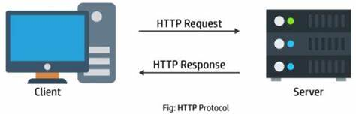

In the above picture client is sending HTTP request to server and in return server is sending HTTP response to client

HTTP methods:

* GET
* POST
* PUT
* HEAD
* DELETE
* PATCH
* OPTIONS

Using above methods, we can perform multiple actions like getting, updating, creating and deleting the data**.**

**For example:**

open(GET,”[www.amazon.com](http://www.amazon.com)”);

send();

Here we are requesting the data from www.amazon.com using GET method.

**Transmission Control Protocol (TCP):**

TCP is a communications standard that enables application programs and computing devices to exchange messages over a network.

**HTTP/1.1:**

HTTP/1.1 is developed by Berners-Lee in 1989 and released in 1997.

In HTTP/1.1 for every single client request a single TCP connection is used between client and server, which means if there are multiple requests then multiple TCP connections are used to exchange the data which will create latency to load the complete web page.

TCP connection established for client request gets deleted when the server receives the request and when server finds the response for the client request a new TCP connection is established to send response to client.

The browser can only have a limited number of TCP connections open which means a browser can only load a single resource.

HTTP/1.1 loads resources one after other, so if one resource cannot be loaded it blocks all other resources behind it.

Lot of requests and responses create multiple TCP connections which leads to latency.

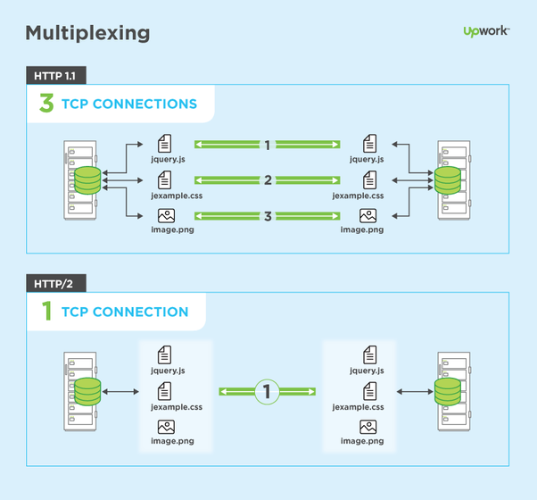

**HTTP/2:**

HTTP/2 is developed by google and released in 2015.

The primary goal of HTTP/2 is to reduce latency by enabling full request and response multiplexing which can make our applications faster.

In HTTP/2 any number of requests and responses can be exchanged through single TCP connection from client to server.

HTTP/2 forces all HTTP headers to be sent in a compressed format, reducing the amount of information that needs to be exchanged between browser and server.

